# Database Programming with SQL

**8-1: Group Functions**

1. Define and give an example of the seven group functions: AVG, COUNT, MAX, MIN, STDDEV, SUM, and VARIANCE.

* AVG: Calculates the average value of a numeric column.

Example: SELECT AVG(salary) FROM employees;

* COUNT: Counts the number of rows or non-null values in a column.

Example: SELECT COUNT(employee_id) FROM employees;

* MAX: Returns the maximum value from a column.

Example: SELECT MAX(salary) FROM employees;

* MIN: Returns the minimum value from a column.

Example: SELECT MIN(salary) FROM employees;

* STDDEV: Calculates the standard deviation of a numeric column.

Example: SELECT STDDEV(salary) FROM employees;

* SUM: Calculates the total sum of a numeric column.

Example: SELECT SUM(salary) FROM employees;

* VARIANCE: Calculates the variance of a numeric column.

Example: SELECT VARIANCE(salary) FROM employees;

1. Create a query that will show the average cost of the DJs on Demand events. Round to two decimal places.

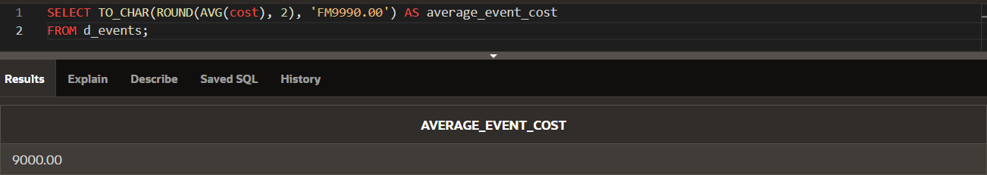

1. Find the average salary for Global Fast Foods staff members whose manager ID is 19.

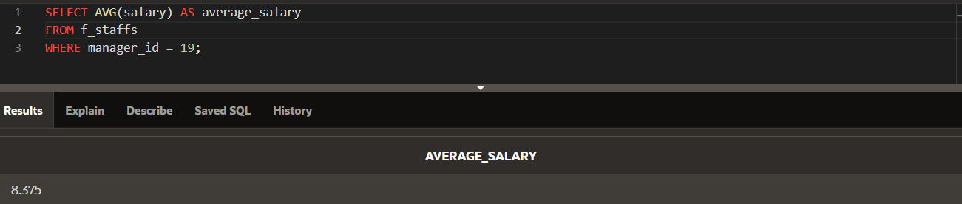

1. Find the sum of the salaries for Global Fast Foods staff members whose IDs are 12 and 9.

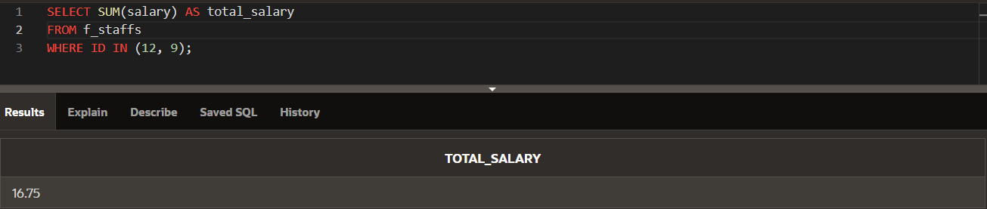

1. Using the Oracle database, select the lowest salary, the most recent hire date, the last name of the person who is at the top of an alphabetical list of employees, and the last name of the person who is at the bottom of an alphabetical list of employees. Select only employees who are in departments 50 or 60.

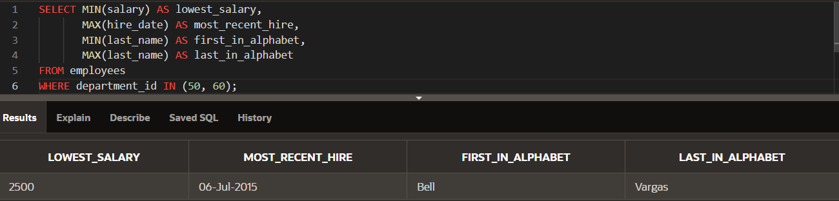

1. Your new Internet business has had a good year financially. You have had 1,289 orders this year. Your customer order table has a column named total_sales. If you submit the following query, how many rows will be returned? SELECT sum(total_sales) FROM orders;
   * + 1 row (the SUM function returns a single aggregated result).
2. You were asked to create a report of the average salaries for all employees in each division of the company. Some employees in your company are paid hourly instead of by salary. When you ran the report, it seemed as though the averages were not what you expected—they were much higher than you thought! What could have been the cause?
   * + **Reason:** The report may include both salaried employees and hourly employees, which would skew the average if hourly wages were not converted to an annualized salary for comparison.
3. Employees of Global Fast Foods have birth dates of July 1, 1980, March 19, 1979, and March 30, 1969. If you select MIN(birthdate), which date will be returned?
   * + **Answer**: The earliest birthdate, which is March 30, 1969.
4. Create a query that will return the average order total for all Global Fast Foods orders from January 1, 2002, to December 21, 2002.

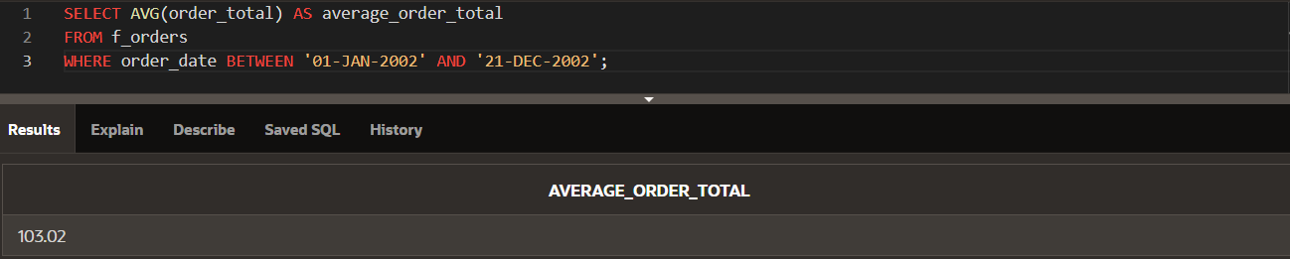

1. What was the hire date of the last Oracle employee hired?

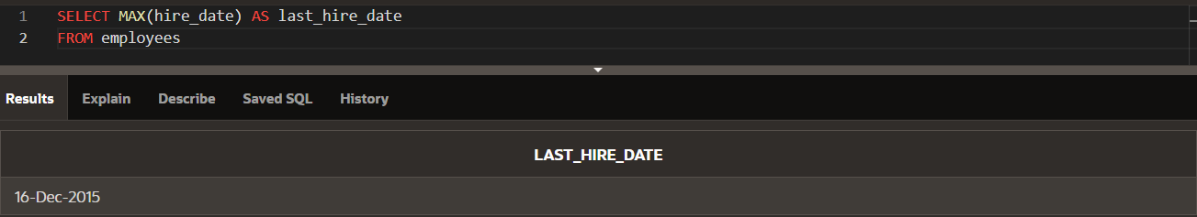

1. In the following SELECT clause, which value returned by the SELECT statement will be larger? SELECT SUM(operating_cost), AVG(operating_cost)
   * + **Answer**: SUM(operating_cost) will always be larger or equal to AVG(operating_cost), as SUM is the total and AVG is the average.

**8-2: Count, Distinct, NVL**

1. How many songs are listed in the DJs on Demand D_SONGS table?

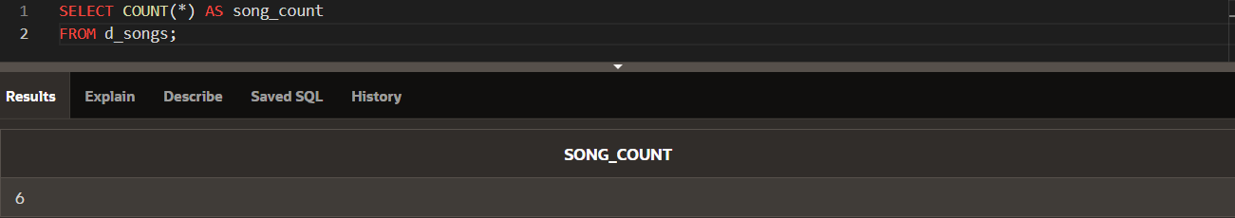

1. In how many different location types has DJs on Demand had venues?

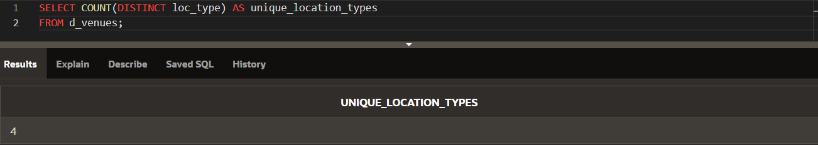

1. The d_track_listings table in the DJs on Demand database has a song_id column and a cd_number column. How many song IDs are in the table and how many different CD numbers are in the table?

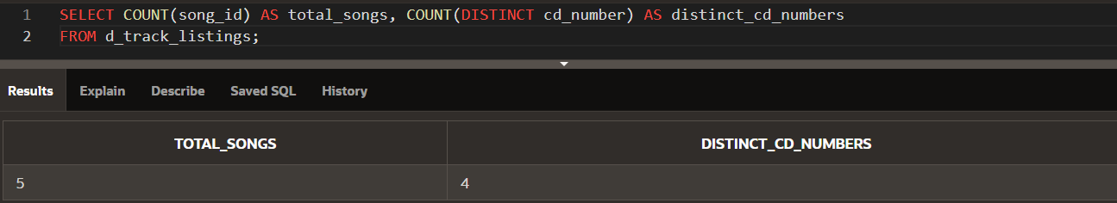

1. How many of the DJs on Demand customers have email addresses?

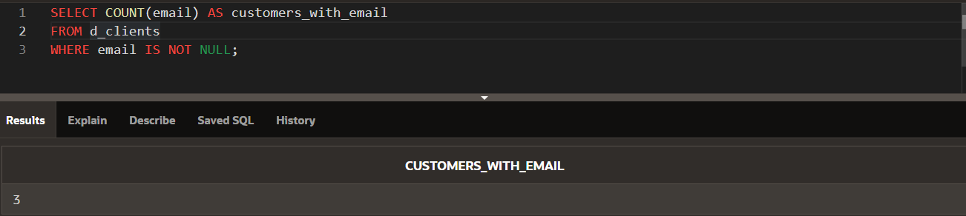

1. Some of the partners in DJs on Demand do not have authorized expense amounts (auth_expense_amt). How many partners do have this privilege?

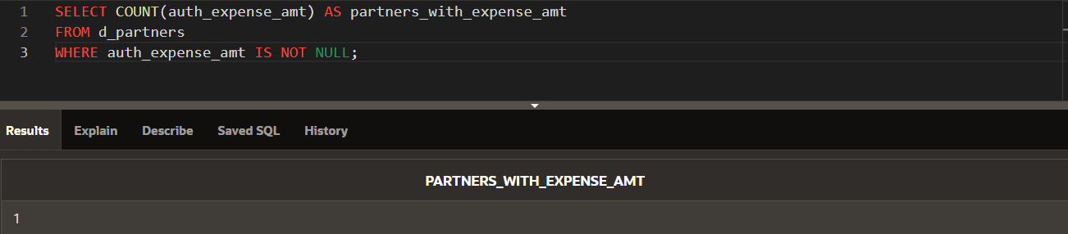

1. What values will be returned when the statement below is issued?

|  |  |  |
| --- | --- | --- |
| ID | type | shoe_color |
| 456 | Oxford | Brown |
| 463 | Sandal | Tan |
| 262 | Heel | Black |
| 433 | Slipper | Tan |

SELECT COUNT(shoe_color), COUNT(DISTINCT shoe_color) FROM shoes;

* + - COUNT(shoe_color) returns 4 (since there are 4 rows with a shoe color).
    - COUNT(DISTINCT shoe_color) returns 3 (since there are 3 distinct colors: Brown, Tan, Black).

1. Create a query that will convert any null values in the auth_expense_amt column on the DJs on Demand D_PARTNERS table to 100000 and find the average of the values in this column. Round the result to two decimal places.

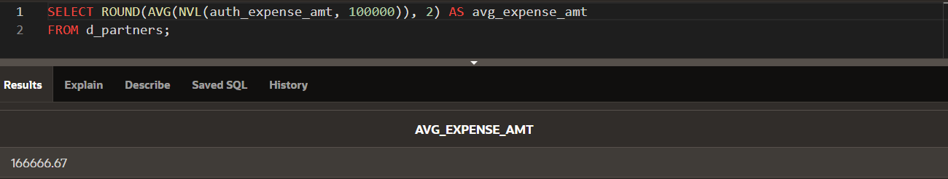

1. Which statement(s) is/are True about the following SQL statement: SELECT AVG(NVL(selling_bonus, 0.10)) FROM bonuses;
   1. The datatypes of the values in the NVL clause can be any datatype except date data.
   2. **If the selling_bonus column has a null value, 0.10 will be substituted.**
   3. **There will be no null values in the selling_bonus column when the average is calculated.**
   4. This statement will cause an error. There cannot be two functions in the SELECT statement.
2. Which of the following statements is/are TRUE about the following query? SELECT DISTINCT colors, sizes FROM items;
   1. Each color will appear only once in the result set.
   2. Each size will appear only once in the result set.
   3. Unique combinations of color and size will appear only once in the result set.
   4. Each color and size combination will appear more than once in the result set.